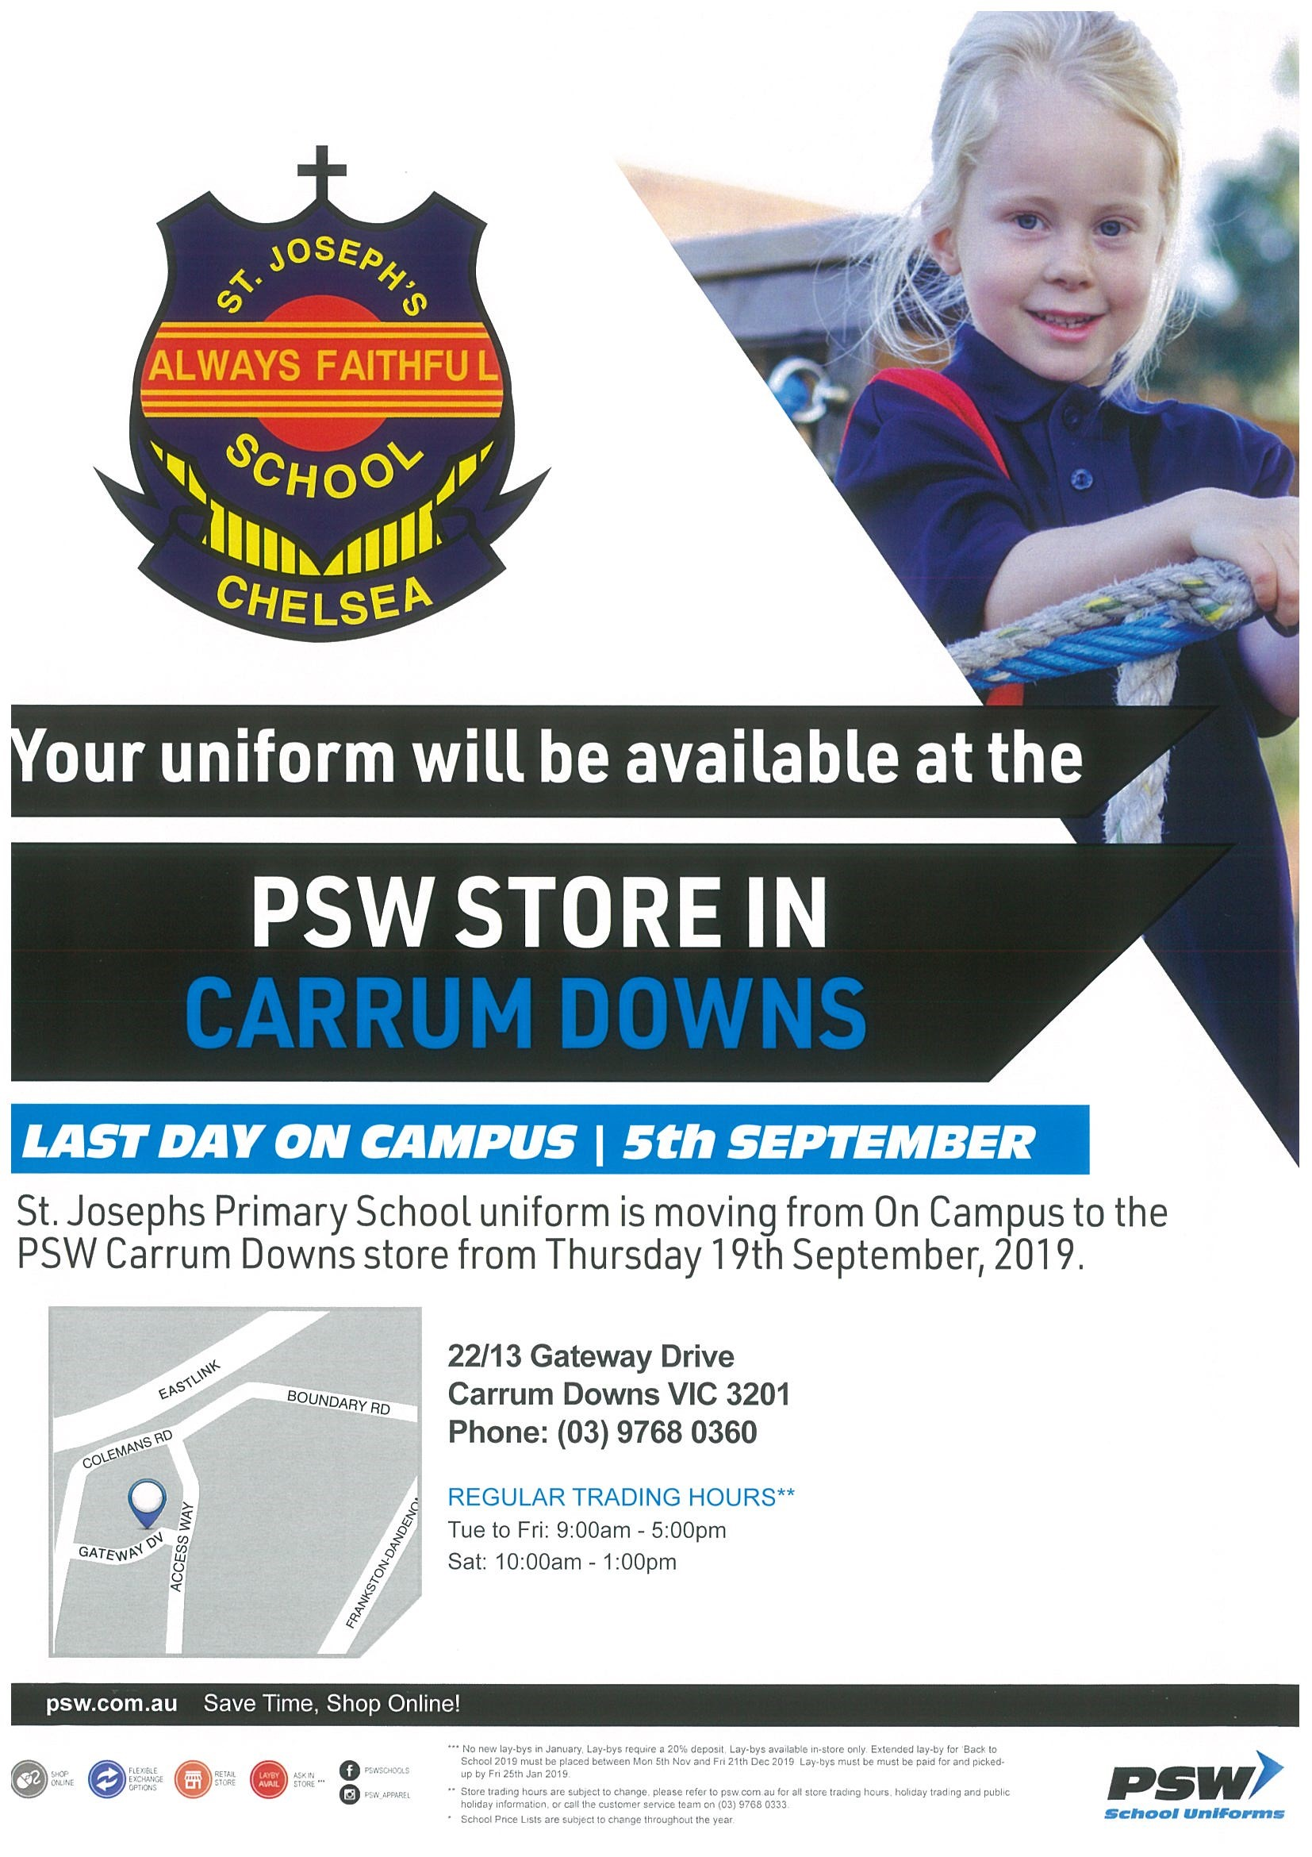
Shop online at www.psw.com.au
ABN 52 007 423 627

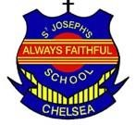
St Joseph's Primary School Chelsea
Uniform Price List
Price as at: 20­08­2019

General |  | Colour | Logo | Size | Price($)
1100105 | S/S Pique Plain Polo Shirt | Sky | NHI | 4­14/XS  16/S­18/M | 25.95  28.95
1100155 | L/S Polo Shirt | Sky | NHI | 4­14/XS  16/S­L | 27.95  30.95
1110355 | Gaberdine Zip Pocket Shorts | Grey |  | 4­14/XS  16/S­L | 22.95  25.95
1100425 | Pleated Trouser ­ Double Knee | Ink |  | 4­18/82cm | 38.95
1110400 | Elastic Waist Pants ­ Yoke Back | Ink |  | 4­14/XS  16/S­L | 32.95  36.95
Female |  | Colour | Logo | Size | Price($)
1103001 | A­Line Shift Dress | Navy_White |  | 4G­18G/12L | 27.95
1104014 | Detachable Bib Tunic with Box Pleat Skirt | Navy |  | 4G­18G/12L | 50.95
1100315 | Culottes | Ink |  | 4G­12G/6L  14G/8L­18G/12L | 25.95  28.95
Sport |  | Colour | Logo | Size | Price($)
1100330 | Rugby Shorts ­ Drawstring | Navy |  | 4­14/XS  16/S­L | 19.95  22.95
1100302 | S/S Polo ­ Contrast Stripe | Navy_Yellow | NHI | 4­14/XS  16/S­L | 27.95 30.95
1100302 | S/S Polo ­ Contrast Stripe | Navy_Red | NHI | 4­14/XS  16/S­L | 27.95  30.95
1100302 | S/S Polo ­ Contrast Stripe | Navy_Emerald | NHI | 4­14/XS  16/S­L | 27.95  30.95
1100302 | S/S Polo ­ Contrast Stripe | Navy_Royal | NHI | 4­14/XS  16/S­L | 27.95  30.95
1100306 | Nylon Windcheater ­ Stripe Rib | Navy_Gold | NHI | 4­L | 36.00
1100307 | Nylon Trackpants­Stripe Rib | Navy_Gold |  | 4­L | 30.95
Accessories |  | Colour | Logo | Size | Price($)
1100200 | Raincoat | Navy |  | 4­­6­12­­14  S­­M­S­­M | 41.95  44.95
1100507 | Legionnaire Hat | Navy | NHI | ALL­ALL | 11.95
1108041 | Adjustable Bucket Hat with Wide Brim & P Navy_Gold |  | NHI | S­XL | 16.95
8302250 | Explorer Bag ­ Contrast Piping Navy_Gold |  | NHI | ALL­ALL | 46.95
Socks | Colour |  | Logo | Size | Price($)
2513000 | Girls Tights Navy |  |  | 4­­6­11­­14 | 11.95
2511050 | Crew Socks ­ 3 pack Grey |  |  | 9­­12­11­­14 | 14.95
2511050 Crew Socks ­ 3 pack Sky 9­­12­8­­11 14.95
PLEASE NOTE: The second hand uniform shop will still be open at St Joseph’s School on Thursday mornings 8.30-8.45. School Jumpers and hats are available from the second hand shop at St Joseph’s Primary School.
Jumpers Size 4-6-8 $45
Jumpers Size 10-12 $54
Jumpers Size 14-16-18 $57
Legionaire Hats $6
Wide Brim Bucket Hat $8

